Programming Assignment #4

(for Ch 5)

Problem Description

Write a program to process a collection of daily high temperatures. Your program should count and print the number of hot days (high temperature 85 or higher), the number of pleasant days (high temperature 60-84), and the number of cold days (high temperatures less than 60). It should also display the category of each temperature. Test your program on the following data:

55 62 68 74 59 45 41 58 60 67
65 78 82 88 91 92 90 93 87 80
78 79 72 68 61 59

Modify your program to display the average temperature (a real number) at the end of the run.

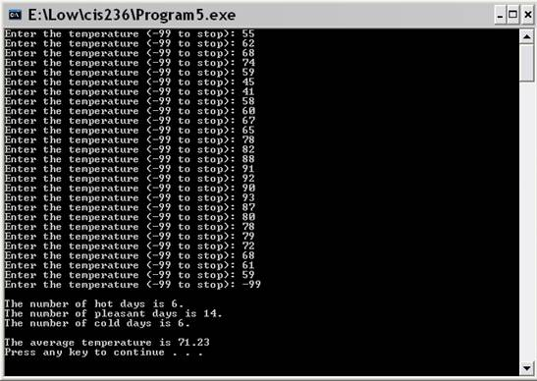

Problem Requirement
a) You must create a file and save it as Program4.c file.
b) The average temperature must be in 2 decimal places.
c) Your program should run correctly with the same inputs and outputs as given in the sample run.

